PPIT SHEET – MID 2

NUCLEARBOT

**SLIDES**

**WHY IS CAPITAL NEEDED?**

To buy the things you need to make the product or to provide the service, and to live while you are making or doing it. Clients and customers usually do not pay before getting the services or product. For any business there must be a certain amount of capital in hand.

**FACTORS INVOLVING CAPITAL**

* salaries, however small, for the founders and for any other staff they may need to employ.
* rent, rates, heating, and lighting of the premises used.
* equipment and consumables.
* costs of advertising and marketing the products.
* miscellaneous expenses, ranging from company stationery to travelling.
* expenses for any trips that may be necessary.
* interest on any money borrowed.

**BUSINESS PLAN DOCUMENT**

1. **Company Description** (Explanation of the company's planned activities, Demonstrating technical feasibility, Highlighting founders' expertise.)

2. **Market Analysis** (Description of the target market, Estimation of market size, Evaluation of competition.)

3. **Financial Projections** (Predictions of the company's financial performance, Includes budgets, cash flow forecasts, projected balance sheets, and profit and loss accounts.)

**Why are Business Plans needed?**

Everyone desires to profit safely. With a business plan, you can seek financial support from potential lenders, investors, or donors.

**SOURCES OF INCOME**

**(i) GRANTS**

Typical grants focus on supporting capital investments, such as facilities and equipment. They often require the recipient to secure funding from other sources and are capped at a percentage of the verified capital investment.

**(ii) LOANS**

A loan is a borrowed sum of money with interest, which can have a fixed or variable rate and is typically for a specific duration. The company is obligated to repay the loan, and in the event of liquidation, the lender can recover it from the company's asset sale. Security is often needed for the loan.

**(iii) EQUITY CAPITAL**

Equity capital is an investment in a company in exchange for ownership shares. Business angels, who are affluent individuals, often offer equity capital to start-ups and small, fast-growing firms. The relationship between loan capital and equity capital in a company is important. It is known as gearing or leverage.

------------X--------------------X--------------------------X------------

**HUMAN RESOURCES (HR)**

**HR ACTIVITIES**

* ensuring that recruitment, selection, and promotion procedures comply with anti-discrimination legislation.
* staff training and development.
* setting up and monitoring remuneration policy.
* setting up and monitoring appraisal procedures.
* administering dismissal and redundancy procedures.
* dealing with contracts of employment.
* workforce planning.
* administering grievance procedures.
* being aware of new legislation affecting employment rights and advising
* management of what the organization must do to comply with it.
* dealing with health and safety.
* administering consultative committees.

**RECURITMENT AND SELECTION**

Human resources managers often make a distinction between the two terms recruitment and selection, **using recruitment is to mean soliciting applications and selection is to mean selecting the applicants to whom offers will be made.** Selection is kept in the hands of the employer, although a member of the recruitment agency staff may sometimes be invited to advise.

**SELECTION TOOLS**

* One-to-one interviews with senior management and technical staff.
* Panel interviews, which can be unreliable and may favor smooth talkers.
* Assessment of references, particularly important for academic and some public sector roles.
* Psychometric tests, including ability, aptitude, and personality assessments.
* Situational assessment, used in military officer selection but expensive.
* Task assessment, where candidates perform job-related tasks, but this approach may not suit larger tasks.

**STAFF TRAINING AND DEVELOPMENT**

Training and development consist of three key activities: training, education, and development, focused on enhancing individual and group performance within an organization. It is also known by various names like "Human Resource Development," "Human Capital Development," and "Learning and Development." In high-tech companies, it plays a crucial role in ensuring performance, and it's unfortunate that it is often the first area to face budget cuts when financial constraints arise.

**Remuneration** is the compensation that one receives in exchange for the work or services performed. Typically, this consists of monetary rewards, also referred to as wage or salary. Several complementary benefits, however, are increasingly popular remuneration mechanisms.

**APPRAISAL SCHEMES**

Performance appraisal is a process to document and assess an employee's job performance. It typically involves regular meetings between an appraiser and an appraisee (employee) to discuss performance and career development, with the outcomes recorded in a jointly signed report. Disagreements on certain points may also be noted in the report.

**DISMISSAL (Causes)**

* lack of capability.
* misconduct.
* breach of the law.
* Redundancy.
* Constructive dismissal.

Dismissal of an employ without valid reasons is unfair.

A fair dismissal of an employee but violating a contract is wrongful dismissal.

**CONTRACTS OF EMPLOYMENT**

The written agreement between an employee and their employer can be enforced in a court of law.

A good contract of employment should be written in terms that are easily understood and should avoid legal conflicts.

* **Job rotation** involves moving employees through different tasks to prevent boredom in highly specialized roles.
* **Job enlargement** expands job responsibilities within the same level, combining various activities to increase the job's scope.
* **Job enrichment** assigns additional responsibilities, typically reserved for higher-level employees, to self-driven employees, fostering motivation and a sense of importance in their work.

---------------X---------------------X----------------------X------------

**INTELLECTUAL PROPERTY**

A **contract** is simply an agreement between two or more people (the parties to the contract) that can be enforced in a court of law. The parties involved may be legal persons or natural persons.

The most important and essential concerns of a contract are that:

* All the parties must intend to make a contract.
* All the parties must be competent to make a contract, that is, they must be old enough and of sufficiently sound mind to understand what they are doing.
* There must be a ‘consideration’, that is, each party must be receiving something and providing something.

**BESPOKE SYSTEMS**

A contract for a customized system typically comprises three components:

- A **concise agreement** signed by the parties, establishing their identities, and emphasizing that prior discussions or writings are not binding.

- **Standard terms and conditions**, typically reflecting the supplier's standard business practices.

- A series of **schedules or annexes outlining the specific details of the contract**, including deliverables, timelines, payment terms, and other relevant specifics.

**ISSUES IN CONTRACTS**

**(i) What is to be produced?**

The contract must specify what will be produced, typically through a requirements specification. To avoid confusion, the reference to the requirements specification should uniquely identify it, often by including a date and issue number. However, addressing any necessary changes during the contract's duration can be a challenge.

**(ii) What is to be delivered?**

The list of possible deliverables includes source code, command files for building and installing executable code, design and code documentation, reference manuals, training materials, software maintenance tools, user training, client maintenance staff training, as well as test data and test results**.**

**(iii) Ownership of rights**

The contract should specify the legal rights transferred from the software house to the client. While physical items like books and documents typically change ownership, intangible rights, such as intellectual property rights, can be more complex to address.

**(iv) Confidentiality**

In the development of a significant custom software system, both parties will gain access to each other's confidential information. To protect their secrets, it's customary for both parties to commit to keeping each other's information confidential, and these terms are typically included in the contract.

**(v) Payment Terms**

A payment structure for a contract should include:

* An initial payment, typically around 15% of the contract value, upon contract signature.
* Intermediate stage payments at different development milestones, adding up to around 65%.
* An additional 25% upon software acceptance.
* A final 10% payment at the end of the warranty period.

**(vi) Calculating Payment for delays and changes**

Delays in meeting project timelines can result in losses for both parties. To address this, the contract should outline the process for calculating additional payments related to the extra work required.

**(vii) Penalty Clauses**

Penalties for supplier-caused delays are often included in software supply contracts but are typically limited in severity due to several reasons:

* Suppliers are reluctant to accept harsh penalty clauses, as stronger penalties can discourage reputable suppliers from bidding.
* Including penalty clauses can raise the bid price significantly, often by at least half the maximum penalty amount.
* If software delivery is substantially delayed, and penalties near their maximum, there's little motivation for the supplier to complete the work since they've already received most of their payments in stages.

**(viii) Standards and methods of working**

The supplier and client often have their own standards, methods, and quality assurance procedures. The contract should clearly state whether the supplier's, clients, or a combination of both sets of procedures will be applied to the project, ensuring clarity in the project's quality control.

**PROJECT MEETING**

Regular progress meetings are essential to the successful completion of a fixed price contract, and it is advisable that standard terms and conditions require them to be held. The minutes of progress meetings, duly approved and signed, should have contractual significance in that they constitute evidence that milestones have been reached (so that stage payments become due) and that delay payments have been agreed.

**PROJECT MANAGER**

Each party in a contract must designate a project manager with clearly defined responsibilities and authority limits. These managers should have the necessary authority to fulfill their contractual obligations, including explicit financial authority limits for approving changes to the contract's cost. This information should be specified in the standard terms and conditions of the contract.

**ACCEPTANCE PROCEDURES**

Acceptance procedures in fixed-price contracts define the criteria for successful project completion. Clients provide predefined tests with expected outcomes, and passing these tests signifies system acceptance. These tests must be established at the outset, and any additional tests are not allowed to ensure timely completion. The contract should also specify participants and the consequences for unsuccessful tests.

**WARRANTY & MAINTENANCE**

After acceptance, a warranty period, usually around 90 days, is offered for free error corrections. The duration is negotiable, impacting the contract's cost. Post-warranty, maintenance is available on request, typically involving software enhancements. It's charged based on time and materials since resource needs are unpredictable, and clients may commit to annual effort days to retain the supplier's system knowledge.

**INFLATION**

In long or maintenance-intensive projects, a clause is often included in contracts to safeguard against inflation. This clause permits cost adjustments to align with rising expenses. The contract should specify the frequency of adjustments (e.g., annually or semi-annually) and the method for calculating the impact on the overall price.

**INDEMNITY**

To protect against unintentional infringement of third-party intellectual property rights due to client instructions or supplier errors, contracts should include a clause where each party indemnifies the other. This means guaranteeing to cover any costs the other party incurs due to their own faults in this regard.

**TERMINATION OF CONTRACT**

Contracts may need to be terminated prematurely for various reasons, such as a client being acquired by a company with a similar system or a change in client policy making the system irrelevant. Contracts should include provisions for an amicable termination, typically involving payment for work completed, compensation for staff redeployment, and addressing ownership of the work done thus far.

**ARBITRATION**

An arbitration clause will usually state that, if arbitration is required, it will take place in accordance with the Arbitration Act 1996. This Act of Parliament lays down a set of rules for arbitration that cover many eventualities, and reference to it avoids the need to spell these out in detail. Most of the provisions of the Act are optional, in the sense that they come into effect only if the contract contains no alternative provision.

**APPLICABLE LAW**

Where the supplier and the client have their registered offices in different legal jurisdictions or performance of the contract involves more than one jurisdiction, it is necessary to state under which laws the contract is to be interpreted.

**CONSULTANCY**

IT consultancy projects typically result in reports or documents. Fees for IT consulting are usually calculated per day, per consultant. Fixed-fee contracts are suitable for well-defined projects, while open-ended consultancy arrangements may favor consulting firms but can risk project and cost overruns due to no time constraints. The contract is usually straightforward.

**CONTRACT HIRE**

Supplier’s responsibility is limited to providing suitably competent people and replacing them if they become unavailable. The staff work under the direction of the client. Payment is on the basis of a fixed rate for each day worked.

Ownership of intellectual property rights generated in the course of the work may be needed to be addressed.

A consultancy contract involves four critical aspects:

1. **Confidentiality**: Consultants must ensure they don't misuse sensitive client information for personal gain.

2. **Terms of Reference**: The contract should explicitly refer to the consultancy team's scope of work, as disagreements often arise when consultants need to address matters beyond their initial terms of reference.

3. **Liability**: Consultants often seek to limit their liability for any client losses resulting from their advice, which may require professional liability insurance.

4. **Control over the Final Report**: The contract typically stipulates that a draft report is presented to the client for review, allowing changes within a fixed period. The revised version submitted by the consultant becomes the final report.

**-----------------------CASE STUDIES-----------------------**

**iGATE: BREACH OF AGREEMENT**

iGATE expanded its operations to India through its subsidiary, Mascot Systems, later renamed iGATE Global Solutions Limited. Offered various IT services, including e-business solutions, application maintenance outsourcing, data warehousing, and ERP package implementation services.

Despite a strong start, iGATE faced difficulties after the dotcom bubble burst. In 2003, iGATE Global acquired a controlling stake in Quintant Services Ltd., a business service provider founded by Murthy and others. Murthy became the CEO and managing director of iGATE Global.

**MURTHY’S JOURNEY WITH iGATE**

After taking charge at iGATE Global, Murthy implemented innovative strategies to position the company competitively. He introduced the **iTOPS (Integrated Technology and Operations) framework, which billed clients based on business outcomes rather than billable hours, challenging the traditional outsourcing model.** This change helped iGATE gain prominence in the market.

Murthy's leadership played a vital role in iGATE's growth. He **revolutionized the billing model by focusing on charging clients based on project outcomes, which appealed to cost-conscious customers**. Under his guidance, the company's financial performance improved significantly. His efforts transformed iGATE from a staffing firm into a globally recognized software services provider.

**FIRING MURTHY: INFOSYS TECH REDUX**

On May 20, 2013, iGATE terminated the employment of its President and CEO, Phaneesh Murthy, due to an ongoing investigation into a **relationship** he had with a subordinate employee and a **claim of sexual harassment**. iGATE's **policy required reporting such relationships**, but the investigation found that Murthy had failed to do so. Although **no violation of iGATE's harassment policy was found, the breach of reporting policy led to his dismissal**. Murthy had faced similar allegations in the past and had previously resigned from a position at Infosys Technologies in 2002 under similar circumstances.

Following Murthy's termination, Gerhard Watzinger was appointed as the interim CEO. **iGATE communicated the situation to its employees** in India via email and a video from 2 of its founders and requested that they refrain from discussing it on social media or with journalists. Many employees expressed concerns about the company's future, as Murthy had played a significant role in its growth and strategy. iGATE faced criticism and a significant drop in its share price, with shares falling around 13% on the day of the announcement.

**MURTHY’S IMMEDIATE RESPONSE**

Following his termination, Murthy organized a teleconference with journalists in India. He expressed his surprise at being terminated and stated that he had not been informed of it **until after office hours**. Murthy admitted to being in a personal relationship with a subordinate, Araceli Roiz, which he described as "more than a friendship" lasting a few months. However, he vehemently **denied the claims of sexual harassment made by Roiz, explaining that she had not filed a legal case but had sent a letter to the company.**

Murthy referred to the situation as a **"clear case of extortion"** and indicated his intention to fight the case if it went to court. He mentioned a previous allegation of sexual harassment made against him in 2002 and suggested that it might be a way to extract money for an alleged reason. Murthy maintained that **he had not** **violated company policy because he had informed the chairman, Sunil Wadhwani, about the relationship with Roiz after it had ended**, though he acknowledged that he should have informed Wadhwani earlier.

When asked if he regretted the relationship, Murthy responded that, in hindsight, he regretted everything that had transpired. **In the subsequent month, he was removed from the board for cause with the majority of shareholders giving their written consent.**

**MURTHY VS iGATE**

In December 2013, Murthy filed a lawsuit against iGATE in a California court. He accused iGATE of various wrongdoings, including **breach of agreements** **(such as his employment agreement and stock option agreement and agreement of good faith & fair dealings)**, **making false promises**, **withholding wages**, and **defaming** him to justify the company's actions. Murthy disputed iGATE's claim of **not knowing about his relationship with Araceli Roiz, arguing that the company had knowledge of the relationship** and improperly used the **reporting policy** as a reason for his termination. **He claimed to have a signed letter from an independent director that confirmed the board's awareness of the relationship** since January 2012.

In the lawsuit, Murthy sought **the release of his more than 500,000 vested stocks**, valued at approximately $18.3 million, **termination benefits** of $1.6 million, and **monthly medical benefits** of $6,000, which he believed he was entitled to for 15 years. He emphasized the importance of honoring employment agreements.

Murthy also stated that, after his termination, he was **promised that he would retain his vested stocks and that the company would expedite a vesting schedule for his unvested stock options as part of his severance package**. However, he alleged that these promises were not fulfilled, and he was **unable to access his company-sponsored trading account to execute his vested stock options**. Additionally, Murthy sought **compensation for the damage to his reputation** caused by repeated defamatory statements made by iGATE to investors and the public.

CONTINUED

**iGATE VS MURTHY**

Following Murthy's termination, iGATE faced several challenges that hindered its growth, including the **loss of a $200 million outsourcing agreement** due to management uncertainties and project delays.

In response, iGATE filed a **countersuit** against Murthy in March 2014, **seeking compensation for damages resulting from Murthy's actions and alleged irresponsible behavior**. The company also claimed legal fees and other costs incurred to address Araceli Roiz's claims against both Murthy and iGATE. The employment agreement included an **indemnification clause** that **required Murthy to indemnify the company for losses due to policy breaches**, reportedly added because of his history of sexual harassment.

iGATE alleged that **Murthy attempted to conceal his relationship with Roiz**, even when the Corporate Governance Committee's chair, Goran Lindahl, raised the matter in response to anonymous Internet postings in 2011. Murthy allegedly dismissed the concerns and entered secret mediation with Roiz **without informing the company**. He **only** notified Wadhwani of the consensual relationship and Roiz's intent to bring a claim after the mediation failed.

Murthy, undeterred by iGATE's countersuit, stated that it was typical to file counter-complaints, expressing his belief in the **wrongful and unfair termination** and his **entitlement to vested stocks and medical benefits**.

------X--------------------X-----------------------X---------------------

**WILL OUR PARTNER STEAL OUR IP?**

Prime ElektroTek, a Taipei-based company that had shifted from manufacturing power supplies to developing hybrid electric power trains for vehicles, had just **secured a deal with Blue Sky Vehicles**, a state-owned Chinese automaker. The announcement was met with excitement from most employees and managers, as it represented a significant entry into the electric vehicle market.

However, one person, Wang Hsi-Guo, the engineer responsible for Prime's power train technology, was not as enthusiastic. He expressed skepticism about the new partnership with Blue Sky. **Wang believed that Blue Sky, once they obtained Prime's components for their prototype, would eventually reverse-engineer and replicate them, potentially becoming a competitor rather than a customer.**

Wang was concerned that the deal might **not lead to long-term prosperity** for Prime. In response, Lin Tung-Hsin, the VP and general manager of the automobile electronics unit, reassured Wang, **emphasizing the importance of engaging with a major customer** like Blue Sky. Wang mentioned Apex Automotive, a Taiwanese company that had been a previous customer and had a positive relationship with Prime due to its **loyalty and collaboration** on prototypes.

The situation highlighted **the tension between seizing new opportunities** in the market and the **risks associated with sharing proprietary technology** with potential competitors.

Prime ElektroTek sought a **strong second-tier partne**r for its auto components business, as working with small companies **wouldn't help it become a major player**. They turned to Blue Sky Vehicles in China, a fast-growing automaker venturing into hybrids. While excited about the partnership, engineer Wang remained cautious, fearing Blue Sky might **reverse engineer their components**. Lin, the VP, disagreed, but Wang was wary of underestimating any Chinese company, highlighting the risks associated with IP protection in China.

**ENTERING THE IP BADLANDS**

Prime ElektroTek was **cautious** about sharing its intellectual property in China, where **companies were known for copying products**. Chinese engineers had a **history of reverse engineering products** in various industries, and **Prime had seen its power supplies cloned by a Chinese computer maker**. They knew that once a trade secret was exposed, it could **spread** to other companies. Laws existed to protect against such actions, but legal action rarely resulted in sufficient damages.

When Prime established a partnership with Blue Sky Vehicles, a fast-growing Chinese automaker, they questioned whether Blue Sky might use Prime's **technology for its own purposes or even sell Prime's components to others**. Lin, the VP, reassured the chairman, pointing out that Blue Sky was only **buying select components**, not everything. He mentioned that Prime had embedded tacit knowledge into some components, **making it difficult for outsiders to replicate** them accurately.

Furthermore, Lin stated that **Blue Sky's engineers didn't seem proficient in systems engineering** during technical discussions. He believed **Blue Sky lacked the expertise** to copy Prime's products. Wang, who had concerns about IP risks, observed that **Blue Sky intended to develop its own vehicle control unit**. Lin saw this as another **sign that Blue Sky was not a significant IP threat**.

However, when Lin later discovered that Prime had disassembled a prototype vehicle control unit built to Blue Sky's specifications, he realized they needed to reconstruct it quickly, possibly due to a change in Blue Sky's intentions or their misunderstanding of the complexity involved. This incident further highlighted the uncertainty surrounding Blue Sky's capabilities in the automotive industry.

**ONE IMPORTANT CONDITION**

A month after the chairman had expressed concerns about the lack of communication from Blue Sky regarding the progress of their prototype vehicle, **Lin was still uncertain about the situation**. The chairman was **anxious about the delay**, emphasizing the importance of the deal with Blue Sky, as their competitors were already ahead in the hybrid car market in China. **Lin made efforts to get updates from his contacts at Blue Sky, but they remained noncommittal**.

Eventually, Lin was invited to see the prototype in Guangzhou. However, the meeting lacked enthusiasm, and **Lin noticed issues with the vehicle's control system during the test drive**. The Blue Sky manager admitted that they were **still working on adjusting the vehicle control unit**. **Lin offered to provide a control unit designed to work with the other components, and Blue Sky accepted the offer.**

Expecting to share this news with the chairman to allay concerns, Lin was surprised by the chairman's agitation during their meeting. The chairman revealed that Blue Sky had a **condition** for accepting Prime's control unit: **they demanded ownership of the intellectual property (IP), including the source code and control system algorithms.** Lin was taken aback, as he had not anticipated such a condition.

The chairman explained that **Blue Sky insisted on having the IP, or they would find another supplier who could provide the complete package**. Lin was left grappling with the dilemma of whether to accept these terms, potentially **compromising Prime's business in China**, or **risk losing the deal** with Blue Sky.

**CONCLUSION**

Over time, Prime ElektroTek **reassured itself that Blue Sky lacked the expertise to reverse engineer and replicate their components**, believing that Blue Sky's engineers were **not highly skilled** in systems engineering.

However, when the progress of Blue Sky's prototype vehicle was **delayed**, Prime ElektroTek **offered to provide a control unit designed to work with their components.** It seemed like a strategic move to address the delay and showcase their capabilities.

Subsequently Blue Sky **demanded ownership of Prime's IP, including the source code and control system algorithms for the control unit**. This condition put Prime in a difficult position, as it risked compromising its IP rights in exchange for a potentially significant business opportunity.

In conclusion, this scenario underscores the fine balance companies must strike between seizing business opportunities and safeguarding their IP.

------X--------------------------X-----------------------X------------

SUNITHA NATH

**SUNITHA NATH: IP CASE (BOMBA??)**

**RAGHU & THE INCIDENT**

**(1) -** Sunitha recognized the need to recruit individuals to manage the day-to-day operations of her growing business. Despite her concerns about hiring the right talent, she was passionate about **mentoring young fashion designer**s and **offering internships**. Sunitha engaged with interns, and by the end of 2011, there were **five interns** working with her, two from NIFT Bengaluru and three from NIFT Bhubaneswar. Among them, **Raghu** and **Samarth** stood out for their exceptional work, dedication, and entrepreneurial spirit. Impressed by their performance, Sunitha offered both jobs as trainee fashion designers at SNB, and they gladly accepted her offer **by signing a one-page appointment letter.**

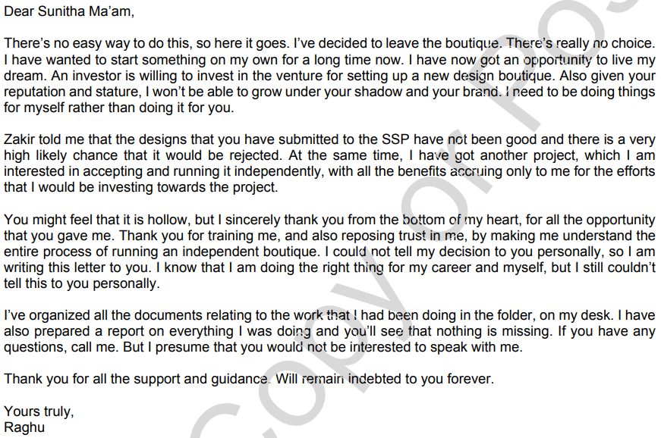**(2) -** Sunitha observed the progress of her trainees, Raghu and Samarth, during their first year of employment. R**aghu showed great potential, was more enterprising and hardworking, and demonstrated a willingness to take on additional responsibilities.** At the end of 2012, Sunitha **promoted** Raghu to **assistant fashion designer, providing him with an updated appointment letter and a 25% salary increase**. Raghu embraced the new role and became even more ambitious and proactive, allowing Sunitha to focus on expanding her business.

As Sunitha explored opportunities in the film industry, **Raghu took on increased responsibilities in the day-to-day operations, focusing on procurement, designing, and sales for the Sunitha Nath brand**. He became **indispensable** in SNB's operations, **initiated process improvements, and negotiated with vendors and clients**. Meanwhile, the "Make in India" campaign and the revival of traditional fabrics and designs **energized Sunitha**, prompting her to launch designer products under the Sunitha Nath brand in the global market.

To handle her extensive travel and client engagement, Sunitha **promoted Raghu to studio manager**, and he **effectively managed SNB's offices and boutiques**. Raghu's efficiency and dedication were **noted by clients and vendors, leading to several job offers with higher salaries.** However, Raghu chose to remain **independent**, recognizing the potential for substantial income, reputation, and career growth in that path.

**(3) -** In 2015, Raghu saw an opportunity **to break away from Sunitha and start his own venture**. It came in the form of a high-budget movie project by StoneStar Santosh Production House (SSP), a prominent player in the Kannada film industry. Sunitha was commissioned to design costumes for the movie, and the project was set in the 17th century Karnataka, requiring traditional Ilakal fabrics. With Sunitha's extensive involvement, she **appointed Raghu as the project coordinator to represent SNB and work with vendors and the movie's production team.**

During this time, Raghu met Zakir, SSP's production manager for the movie, and **put in tremendous effort to ensure the project's success**. However, he suddenly disappeared, and **Sunitha received a letter from him containing unknown information**. Concerned about his absence, Sunitha contacted her legal advisor, Rajashri, to address the situation.

LETTER:

**(4) -** Sunitha and Rajashri were close friends. **Rajashri specializing in intellectual property rights** through her law degree. Rajashri initially worked in a prestigious law firm in Mumbai, but the two friends remained in touch despite Rajashri's busy schedule.

However, when Rajashri returned to Bengaluru and established her independent law practice, **she started assisting Sunitha with legal compliance matters for her fashion business**. Sunitha reached out to Rajashri in a state of panic after receiving Raghu's letter. Rajashri assured Sunitha that she would visit her office immediately to discuss the situation and advised Sunitha **not to disturb anything** until her arrival.

**(5) -** Raghu, **after meeting** **someone from SSP regarding the movie project**, began behaving unusually and **expressed a desire to start his own venture** instead of working for SNB. He claimed that designs prepared by **Sunitha were not satisfactory** for the movie project. Additionally, Raghu mentioned that **Zakir, who was involved in the film project, had suggested he go independent and was willing to invest in his venture**. Raghu discussed the idea of **replicating SNB's processes** at his new boutique, supported by Zakir's investment.

Samarth further revealed that **Zakir was the one who introduced the idea to Raghu** and was **investing in his venture.** This news shocked Sunitha, as **Zakir had previously created difficulties for SNB with the movie project**. Sunitha tried contacting Zakir and the movie director but couldn't reach them.

Sunitha then received an **email from Zakir**, which turned out to be a **contract termination letter,** confirming **Raghu's involvement with the movie project as an independent costume designer**. Realizing that Raghu had **deceived her by stealing critical business information** and her client, Sunitha became increasingly distraught, reflecting on where she might have made mistakes in managing her business.

**(6) -** Sunitha informed Rajashri about the entire situation, including details provided by Samarth, and shared Raghu's resignation letter and the contract termination letter from Zakir. The two then began **reviewing the company's financial records**. Sunitha mentioned that **Raghu had authorization over the company's bank accounts and Internet banking, prompting Rajashri to suggest reviewing the bank statements and payment register for any unauthorized or suspicious transactions**. She advised Sunitha to **change the Internet banking password** immediately.

Upon reviewing the financial records, **they discovered a suspicious payment of ₹400,000 made to an interior designer called M/s Innovative Interior Design**. Sunitha contacted the CEO of M/s Innovative, Shyam Kumar, who **explained that the payment was for interior design work on a new office in Fraser Town, Bengaluru**. **Raghu had authorized the work, even though Sunitha had no plans for such an office**. Kumar also mentioned that Raghu had requested the designer to improvise on SNB's regular office design.

Rajashri concluded that this **indicated theft**, and Sunitha could potentially **have Raghu arrested and face criminal prosecution.** To proceed, Rajashri directed Sunitha to collect more information about the interior design transaction, including the authorization, property lease details, property owner, and documents related to the work.

**(7) -** Rajashri **reviewed SNB's contract with SSP for the movie costumes, and she believed that SNB might still be entitled to some benefits as a result of SSP's abrupt termination.** She noted that the calculation of what was owed would depend on the **timing of the termination**. Sunitha provided more context, explaining that the costume designs had been finalized during the pre-production review stage, and SNB had already delivered the costumes one week before the production start date. Some units were later rejected by Zakir, who claimed the director didn't like them. **Sunitha argued that technically, they couldn't reject the costumes since they had approved the designs, fabrics, stitching, and other details.** Despite this, they sent a rejection notice and later issued a contract termination letter.

Of the total ₹12 million (US$178,000) contract value, SSP had paid ₹6 million (US$89,000) to SNB, with the third installment due at the beginning of the production stage.

Sunitha was also concerned about her **reputation**. She was upset that **SSP had terminated the contract without allowing SNB to respond**. The contract stipulated that SNB's work should meet the satisfaction of the director, while the termination notice claimed that the work did not meet the director's requirements. Sunitha **wondered if the rejection process was part of a plan to terminate the contract with SNB and give the work to Raghu**.

------------X-----------------------X---------------------X--------------

ENSIGHTEN

**ENSIGHTEN CASE STUDY (AND SLA STUFF)**

**WEB ANALYTICS & TAG MANAGEMENT**

The problem addressed in this passage concerns the **difficulty of tracking consumer behavior on websites**. Initially, web marketers and managers struggled to track user data through weblogs, which offered a detailed map of browser activity but were challenging to analyze. **Page tagging**, introduced around 2002, became the alternative approach, **involving the placement of invisible code on web pages. This code would communicate with analytical applications, collecting information on various user interactions, such as the source of website visitors, clicks on links, time spent on pages, and exit destinations**.

Numerous analytical applications adopted this method, serving different purposes:

- Advertising tools for tra**cking ad campaign effectiveness,** affiliate traffic, and retargeting efforts.

- **Analytics packages for monitoring user origins, duration of stay, clicked links, purchase behavior, and navigation patterns**.

- Testing and optimization tools that **compared different webpage** versions.

- Voice-of-customer **packages for gathering consumer feedback**.

Each page could have multiple tags, ranging from 10 to 50, for **tracking various data points and activities**, further complicating the data management process. In some cases, companies **had over 1 million tags** to manage. This complexity posed challenges in implementing and tracking the effectiveness of advertising campaigns, often requiring extensive IT resources and time to manage.

**ENSIGHTEN’S SOLUTION**

In response to the challenge of tracking user data on websites, Manion and a small team of coders **developed a simplified solution**, which they tested with several Stratigent customers. They believed this solution was a significant breakthrough, as it **allowed quick data tracking without compromising data quality and complexity**. In late 2009, Manion formally established **Ensighten** LLC with his wife as a separate company. **Patents were filed for the core technology**, and Manion formed a small team. He focused on Ensighten and moved to Silicon Valley in **September 2010**.

The company bootstrapped its way to building the product, keeping their efforts under wraps initially. **They aimed to complete the product, secure customers, and grow as a company**. When they began to gain traction, they moved to Silicon Valley and announced their product and **first five customers** in September 2010. The venture started with around **six developers and three salespeople, with approximately $1 million in capital investment from Manion and his wife**. Although they moved to Silicon Valley, they decided against raising venture capital, deeming it unnecessary at that point.

Ensighten's product was **cloud-based**, relying on contracts with major server capacity providers across the globe. **The service involved billions of requests each month, with pricing based on the number of client websites or domains and their traffic volume**. A typical early deal included approximately $200,000 in annual licensing fees and a $25,000 setup charge. **Ensighten developed rules** to determine which tags were placed on different pages, resulting in numerous tag permutations. **Once clients started using the application, it became integral to their operations, saving them months of work and enhancing their functionality.**

However, one of the **major challenges** Ensighten faced was **convincing large enterprises to trust them as a mission-critical platform in their infrastructure**. Initial clients required more robust terms, including source code escrow, transition plans, and contract termination restrictions, to establish this level of trust.

**DEVELOPING A TEMPLATE CONTRACT**

Ensighten **initially used a template for software license agreements with its first clients, and these agreements helped the company understand which terms were negotiable and significant**. In the early stages, negotiations mainly focused **on business terms without much legal counsel involvement on either side**. Some non-negotiable terms related to Ensighten's intellectual property and indemnification clauses that could jeopardize the business.

However, when Ensighten landed a substantial deal with a major apparel company, they **encountered challenges** 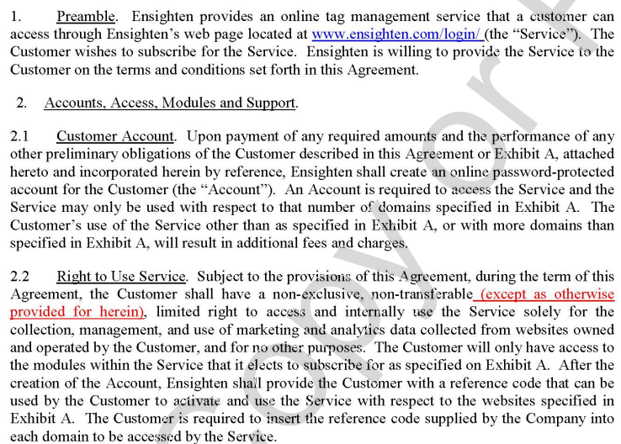with the **client's contract**. This **contract was more suitable for a consultant rather than a software licensor like Ensighten, which caused complexities**. To address these legal challenges, Ensighten brought **in Jim Quinn**, an **attorney specialized in intellectual property** issues in the technology space. Jim helped resolve the issues with the apparel company's contract.

Manion learned from this experience and aimed to handle most legal aspects on his own to avoid excessive legal fees. Jim Quinn provided his expertise when needed but **had not met Manion in person**. They maintained a professional relationship where Manion sought Quinn's assistance for specific agreement sections, understanding the need to manage legal costs carefully.

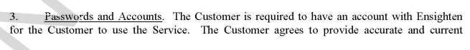Jim Quinn **explained the changing nature of software licensing in the cloud era, where customers gained the right to access software in the cloud without having a copy of it**. Customers **use a small piece of software as a connector, but the bulk of the functionality occurs in the cloud, altering traditional licensing models**. Quinn emphasized that **understanding this shift was crucial** for legal agreements in the cloud computing era.

**GMI**

GMI, a $70 billion company with global media properties, **sought an extensive tracking solution** to monitor customer behavior on its websites**. Ensighten engaged in negotiations with GMI**, which began in October 2010, and had made substantial progress on the business terms by early November. **However, when GMI submitted a redline version of Ensighten's standard licensing agreement with requested changes, Manion was cautious about accepting certain modifications**.

Recognizing the **significance** of the deal, Manion decided to **involve Jim Quinn**, the attorney who had previously assisted Ensighten in legal matters. GMI was using outside counsel for negotiations since, **for a company of its size, a $200,000 deal did not justify diverting its general counsel and legal staff from core legal issues**. Quinn's involvement was **seen as an essential step** to navigate the negotiations effectively. Manion wanted to **ensure that potential compromises align with Ensighten's objectives and that both parties could reach an agreement beneficial to both sides**.

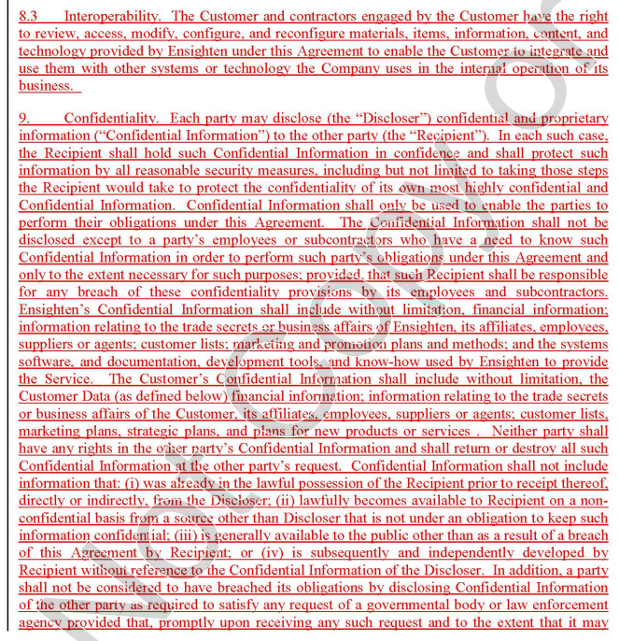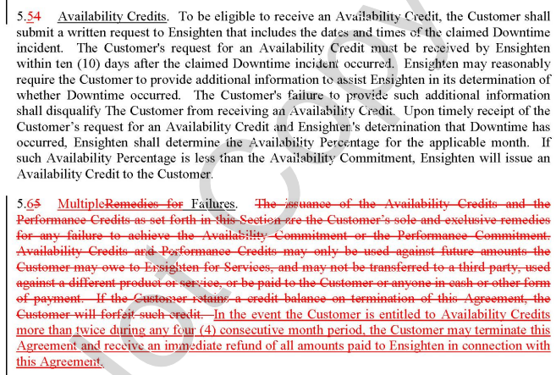

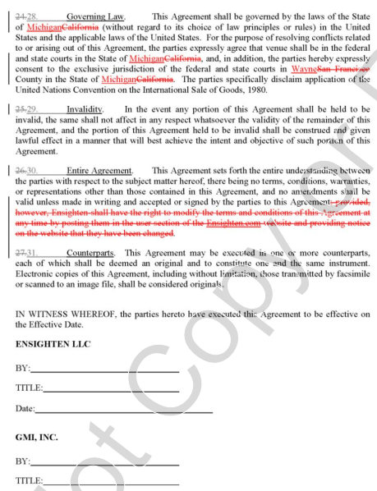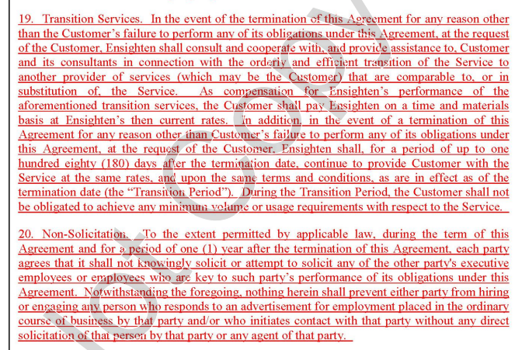

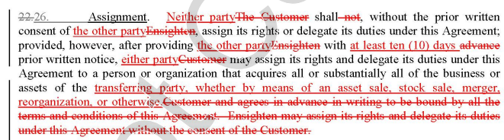

**NDA TEMPLATE**

This NDA outlines an agreement between a "Company" (the disclosing party) and a "Recipient" (the receiving party) to protect the confidentiality of a business plan and related information. It includes the following key sections:

**Article I: Recitals**

-This section provides **background information** about **the purpose of the agreement**. The Company wishes to share its business plan while maintaining confidentiality. Confidential Information is defined as all information, strategies, plans, trade secrets, objectives, and materials.

**Article II: Recipient Obligations**

- **A.** **Non-Disclosure**: The Recipient agrees **not to use** or disclose the Business Plan or Confidential Information for personal benefit or **to any third party**. The Recipient must take steps to protect this information from disclosure.

- **B. Disclosure:** The Recipient can only disclose the Business Plan and Confidential Information to **individuals within their organization on a need-to-know basis**. All individuals privy to this information must also be bound by the **terms of this Agreement**.

- **C. Exceptions**: The Recipient is **not prohibited from disclosing information that is publicly known**, was already in their possession before the agreement, is required by law, or has written approval from the Company.

- **D. Legal Obligation:** If compelled by **legal processes, the Recipient can disclose Confidential Information**, provided they promptly notify the Company and take legally available steps to resist or narrow such requests.

**Article III: Term**

- This section **allows the Parties to select whether the Recipient's obligations will remain in effect indefinitely or for a specified number of years** **(or in perpetuity)** from the Effective Date.

**Article IV: Return or Destruction of Confidential Information**

- The Recipient must **return or destroy** all materials related to the Confidential Information upon termination of the Agreement or as per the Company's request.

**Article V: No Additional Agreements**

- This section clarifies that **discussions and information exchange don't create any obligation** for the Company to enter into further agreements with the Recipient or prohibit them from providing similar information to others.

**Article VI: Indemnify**

- The Recipient agrees to indemnify (compensate) the Company against any damages or losses resulting from a breach of the Agreement. Recipient understands and acknowledges that any use or disclosure regarding the Business Plan or Confidential Information could cause the Company irreparable harm, **the amount of which may be difficult to ascertain, and therefore agrees that the Company shall have the right to apply to a court of competent jurisdiction for specific performance or order restraining and enjoining any such further disclosure or breach and for such other relief as Company deems appropriate**, in addition to the remedies otherwise available at law or in equity.

**Article VII: Successors and Assigns**

- The obligations of this Agreement are binding on the representatives, assigns, and successors of the Parties. However, the Recipient's rights and obligations are not assignable.

**Article VIII: Governing Law**

- The Agreement is governed by the laws of a specified state.

**Article IX: Prevailing Party**

- In case of a dispute, the **prevailing party has the right to collect attorney fees, costs, and other legal expenses** from the other party**.**

**Article X: Entire Agreement**

- This Agreement supersedes all prior agreements and must be altered, amended, or modified in writing by both Parties.

**Article XI: Validity**

- If any provision is **deemed unenforceable by a court, it will be interpreted to preserve** its intent.

**Article XII: Notices**

- The section outlines how notices should be provided and includes spaces for the Parties' addresses.

The Agreement ends with a **signature section** for both the Company and the Recipient, **including signature, date, printed name, and title** for each party.